MINI PROJECT
ML-DA-DAF 69
ANNIE ALBERT

Opened the CSV file in excel
Insert Filter Ctl+Shft+L
Missing Value
Age:
=IF(ISBLANK(D2),MODE($D$2:$D$980),D2)
Replaced missing age with Mode
UREA:
Replaced missing data with Median
=IF(ISBLANK(F2),MEDIAN($F$2:$F$1010),F2)
Creatinine:
Replaced missing data with Median
=IF(ISBLANK(H2),MEDIAN($H$2:$H$1010),H2)
HBA1c
Replaced with Average
=IF(ISBLANK(J2),AVERAGE($J$2:$J$1010),J2)
Cholestrol
Replaced missing data with Median
=IF(ISBLANK(L2),MEDIAN($L$2:$L$1010),L2)
TG
Replaced missing data with Median
=IF(ISBLANK(N2),MEDIAN($N$2:$N$1010),N2)
HDL
Replaced missing data with Median
=IF(ISBLANK(P2),MEDIAN($P$2:$P$1010),P2)
LDL
Replaced missing data with Median
=IF(ISBLANK(R2),MEDIAN($R$2:$R$1010),R2)
VLDL
Replaced missing data with Median
=IF(ISBLANK(T2),MEDIAN($T$2:$T$1010),T2)

Removed Duplicates in No_Pation Column
Considering this as unique ID
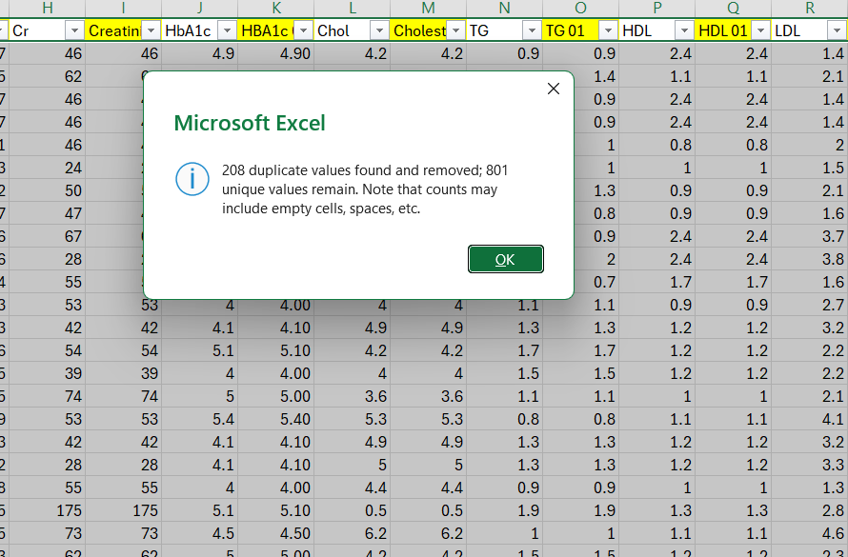

Created a column BMI Category
=IF(V2<18.5,"Underweight",IF(V2<25,"Normal",IF(V2<30,"Overweight","Obese")))
Standardized Class column
=IF(X103="N","Normal", IF(X103="P","Prediabetes", IF(X103="Y","Diabetic",)))
Converted to Table
Pivot Table
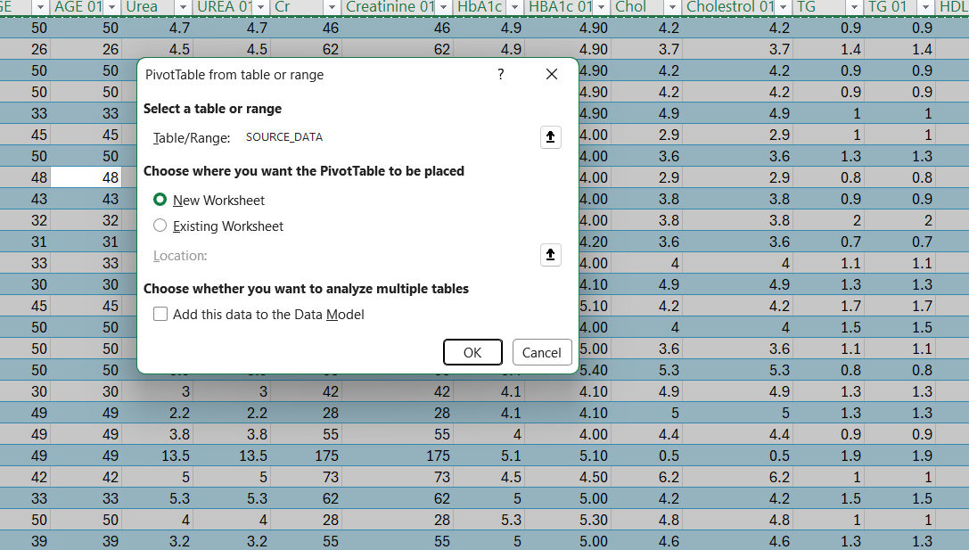
Pivot tables
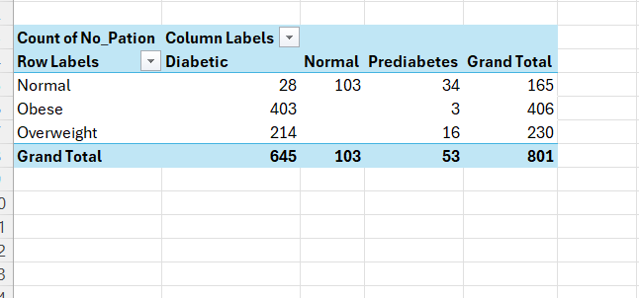
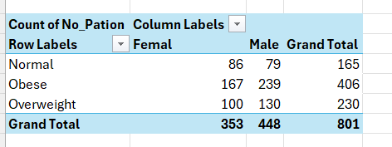
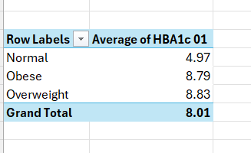
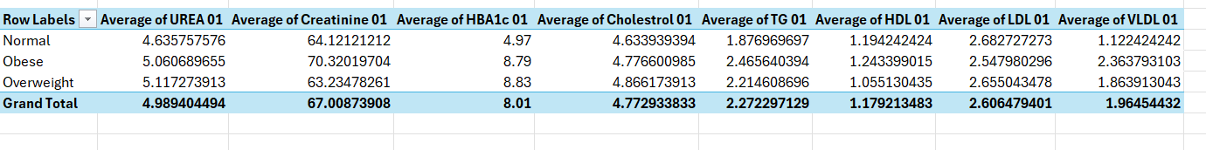
Inserted Charts
After selecting Pivot table go to insert then charts
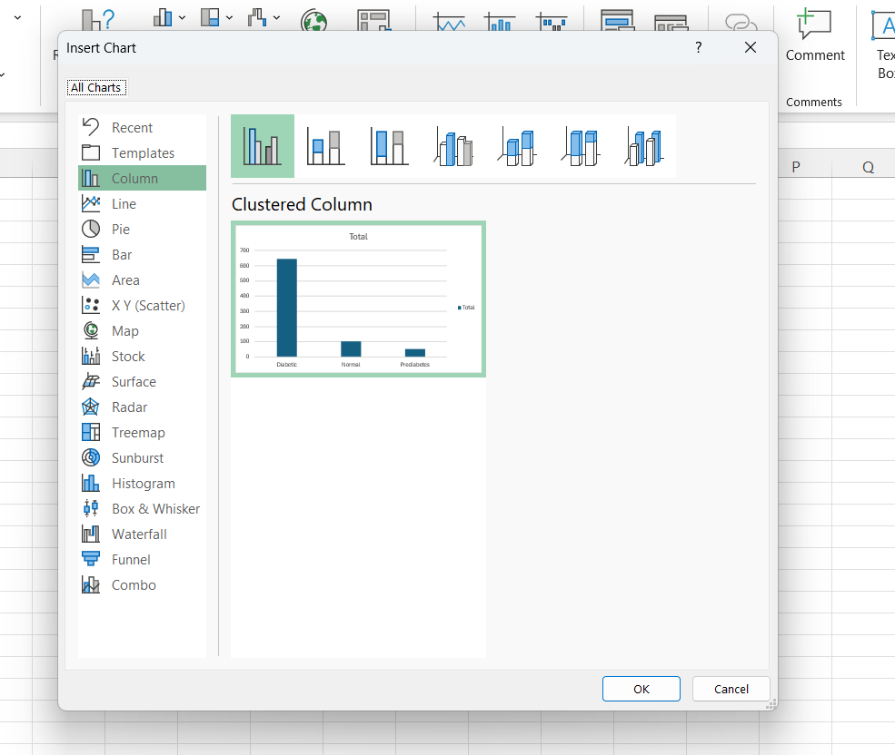

Created all charts

Dash Board
Open a new sheet copy all charts and arrange
Then select a chart the Pivotchart Analysis
Insert Slicer
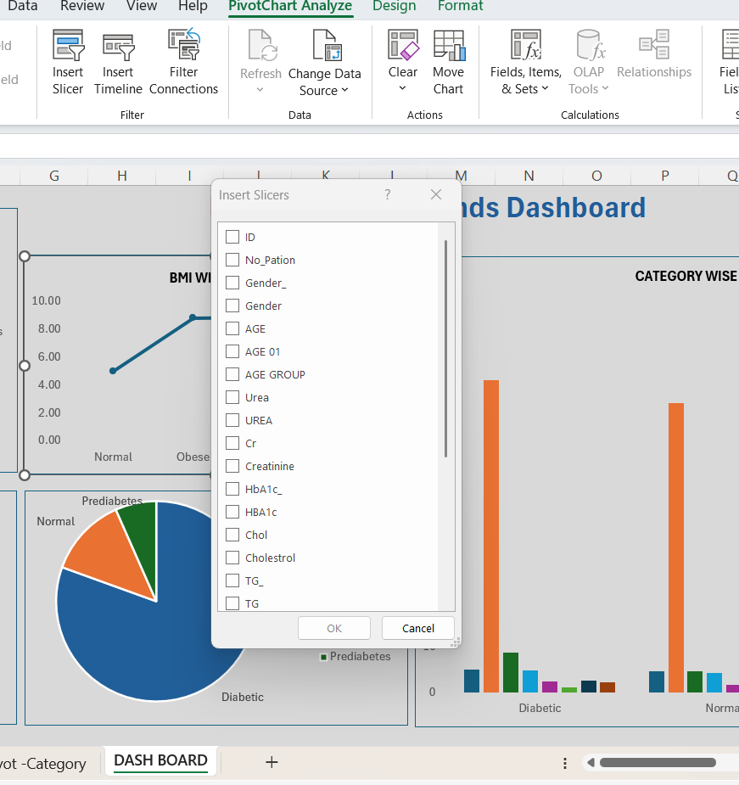

Final dash board
